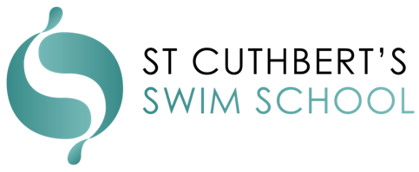
PRIVATE LESSON’S TERMS & CONDITIONS
- St Cuthbert’s Swim School private lessons are separate from perpetual bookings. The full payment is required upon booking. We require a minimum of 4 private lessons to be booked.

- We do not offer make-up lessons or credits for private lessons. There is the ability to waive this if it is due to a serious medical issue. This is at the discretion of management and may require supplementary documentation, e.g., a medical note.

- Cancellation of the private lesson must be made in writing via email (swimbookings@stcuthberts.school.nz). Verbal cancellations are not accepted. All cancellations for private lessons must be made at least 24 hours in advance. If the cancellation is made 24 hours in advance, then we will issue a credit for the lesson. If the cancellation is made less than 24 hours in advance, you will be charged for the lesson missed. There is the ability to waive this if it is due to a serious medical issue. This is at the discretion of management and may require supplementary documentation, e.g., medical notes.

- If your instructor is sick or away, we will try to provide an alternative instructor. If we cannot provide an alternative or you are not happy with the alternative, then we will cancel the private lesson cost with no charge and refund the amount for the lesson missed.

- All users must abide by and follow 1.0-1.18 of our terms and conditions, which can be found on our Swim School Terms and Conditions page.

- We do not accept tentative bookings. Bookings are taken as confirmed once they have been made.

- St Cuthbert’s Swim School reserves the right to change any teacher at any time at our discretion.

- CCTV is in place at St Cuthbert’s Swim School. We reserve the right to monitor the safety of our facility, Swim School, teachers, and participants. Sometimes, we may film or photograph the Swim School when it is in use for promotional, educational, and marketing purposes within our business. You may appear in the background of any promotional or marketing material. By signing this agreement, You agree to allow us to use images of You.

- To maintain excellent standards of cleanliness for the Swim School pools, all Participants (excluding babies) must wear a swimming cap while using either of the Swim School pools. Participants under three years old must also wear a swimming nappy.

- On Swim School registration, you will provide us with, and we will hold on to your personal information. We will only use, deal with, or disclose your personal information in a way consistent with our privacy policy.

- Our primary method of communication is via email. It remains the client’s responsibility to keep us up to date with all their current contact information.

- Your Acknowledgement and Acceptance By joining the Swim School, You agree that You have been given the opportunity and have read and understood St Cuthbert’s Swim School Terms and Conditions set out above, and You agree to be bound by them.

